**Thermal Shock Modello ATSS-30**

***Nuovi standard:***

➔ Impronta minima > Migliore utilizzo dello spazio

➔ Camera multiuso > Riscaldamento e Raffreddamento in entrambi i vani

➔ Margini di Set-Point > Pre-Raffreddamento e Pre-Riscaldamento

➔ Prestazioni elevate > Secondo Standard IEC, MIL-STD, JEDEC, IPC, etc.

➔ Sistema di Controllo > Programmatore con Touch Screen a colori da 12”

➔ Efficiente Ventilazione > Massima uniformità

**Tutto questo per il Miglioramento della produttività**

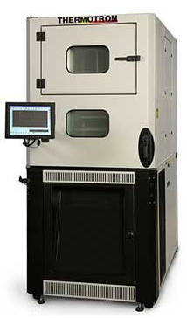

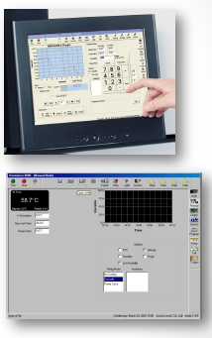



**Misure Cestello 300x350x300 mm LxPxH**

• Zona Calda da +25°C a +215°C

• Zona Fredda da -73°C a +180°C

**Scelta tra due sistemi di refrigerazione**

• Doppio stadio con due compressori da 2 hp in cascata

• Doppio stadio con due compressori Scroll 4 hp in cascata

**Misure Esterne 870x1780x2040 mm LxHxP**

• Ideale per passare attraverso la maggior parte delle porte

# ATSS-30-2-2 Thermal Cycling & Thermal Shock Chamber

|  |  |
| --- | --- |
| **Transfer Basket Dimensions—WxDxH:** | 12 x 14 x 12 inches 30 x 35 x 30 centimeters |
| **Temperature Range Hot Zone:** | +25°C to +215°C (+77°F to +419°F) |
| **Temperature Range Cold Zone:** | -73°C to +180°C  (-100°F to +356°F) |
| **Temperature Control Tolerance:** | +/-1.1°C (+/-2°F) |
| **Approx. Shipping Weight:** | 1,400 lbs 637 kg |
| **Maximum Weight Capacity in Basket Pounds / Kg:** | 20 lbs 9 kg |
| **Move-In Dimensions—WxDxH:** | 34 x 70 x 80 inches 87 x 178 x 204 centimeters |
| **Electrical Requirements in Full Load Amps 460 / 3 / 60:** | 36 |
| **Electrical Requirements in Full Load Amps 400 / 3 / 50:** | 39 |
| **Electrical Requirements in Full Load Amps 230 / 3 / 60:** | 60 |
| **Electrical Requirements in Full Load Amps 208 / 3 / 60 :** | 66 |
| **Compressor Size:** | (2) 2 1/2 Hp Air-cooled |
| **Airflow:** | 400 SCFM (11.3 cubic meters / minute) |

##### Notes

Environmental chamber performance is based upon 60 Hz and laboratory ambient conditions of 23.9°C (75°F) with 50% relative humidity and may vary slightly on 50 Hz power or at other temperature and humidity levels.

It is Thermotron’s understanding that the environmental chamber will be used in a non-hazardous environment. The test chamber is not designed for use with or for the purpose of processing hazardous materials. If hazardous materials are involved, please consult the factory for an alternative quote for a properly designed unit.

Environmental Chambers are not designed for open petroleum products. Any applications involving open transmission fluids, oils, etc. need to be examined by the applications group for suitable protection.

Specifications are subject to change without notice.

# ATSS-30-4-4 Thermal Cycling & Thermal Shock Chamber

|  |  |
| --- | --- |
| **Transfer Basket Dimensions—WxDxH:** | 12 x 14 x 12 inches 30 x 35 x 30 centimeters |
| **Temperature Range Hot Zone:** | +25°C to +215°C  (+77°F to +419°F) |
| **Temperature Range Cold Zone:** | -73°C to +180°C  (-100°F to +356°F) |
| **Temperature Control Tolerance:** | +/-1.1°C (+/-2°F) |
| **Approx. Shipping Weight:** | 1,480 lbs 671 kg |
| **Maximum Weight Capacity in Basket Pounds / Kg:** | 20 lbs 9 kg |
| **Move-In Dimensions—WxDxH:** | 34 x 70 x 80 inches 87 x 178 x 204 centimeters |
| **Electrical Requirements in Full Load Amps 460 / 3 / 60:** | 39 |
| **Electrical Requirements in Full Load Amps 400 / 3 / 50:** | 45 |
| **Electrical Requirements in Full Load Amps 230 / 3 / 60:** | 66 |
| **Electrical Requirements in Full Load Amps 208 / 3 / 60 :** | 72 |
| **Compressor Size:** | (2) 4 Hp Air-cooled |
| **Airflow:** | 400 SCFM (11.3 cubic meters / minute) |

##### Notes

Environmental chamber performance is based upon 60 Hz and laboratory ambient conditions of 23.9°C (75°F) with 50% relative humidity and may vary slightly on 50 Hz power or at other temperature and humidity levels.

It is Thermotron’s understanding that the environmental chamber will be used in a non-hazardous environment. The test chamber is not designed for use with or for the purpose of processing hazardous materials. If hazardous materials are involved, please consult the factory for an alternative quote for a properly designed unit.

Environmental Chambers are not designed for open petroleum products. Any applications involving open transmission fluids, oils, etc. need to be examined by the applications group for suitable protection.

Specifications are subject to change without notice.

**Software familiare stile Windows**

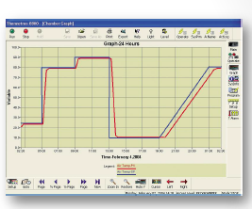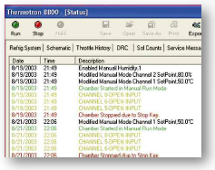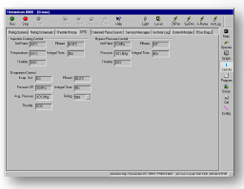

**Facile accesso a tutti i componenti per la manutenzione**

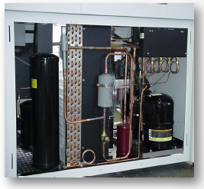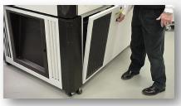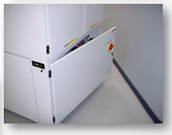

**Praticità e Funzionalità per un uso professionale**

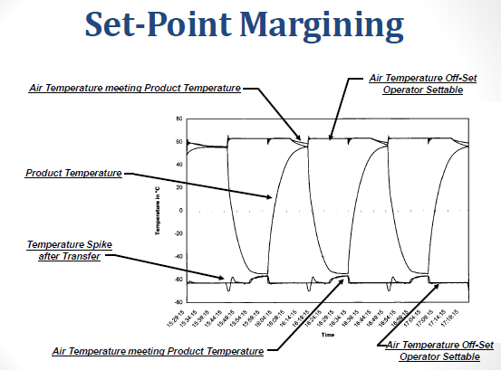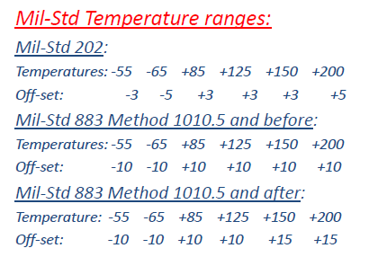

**Installazione, Addestramento e Assistenza**

